

WORKDESK

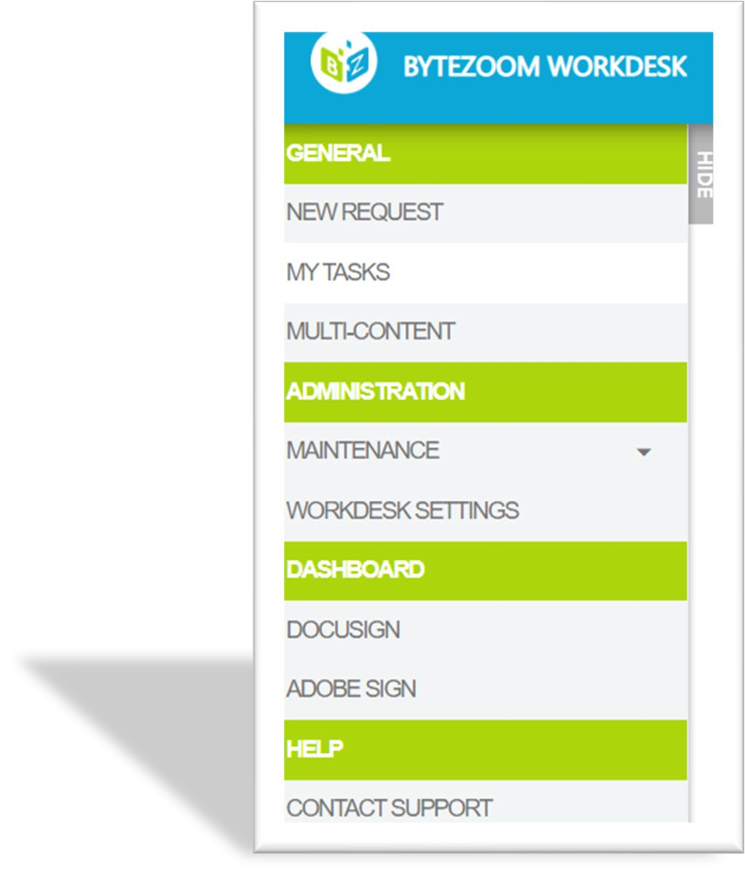

User guide

December 2020

Copyright © 2014 – 2020 Bytezoom LLC [http://www.bytezoom.com](http://www.bytezoom.com/)

# Contents

Creating Deployment Artifacts 3

SQL Database schema and data 3

K2 Forms, views and SmartObjects 4

Bytezoom Workdesk Deployment 5

SQL database schema and data 5

Service Instance 6

K2 Forms, views, SmartObjects 7

Workdesk Settings 8

Configurations 8

Logos 11

Applications 13

Workdesks 15

Links 18

Roles 22

Roles members 24

## Creating Deployment Artifacts

Once customizations and configuration are created, it is useful to deploy the Workdesk to other environments, such as QA and Production. This section describes how to create deployment artifacts.

SQL Database schema and data

1. Open Microsoft SQL Server Management Studio.

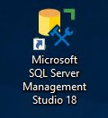

1. Expand Databases in Object Explorer.

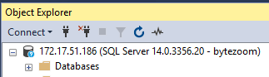

1. Right click on BytezoomWorkdesk database.
2. Select Tasks > Generate Scripts.

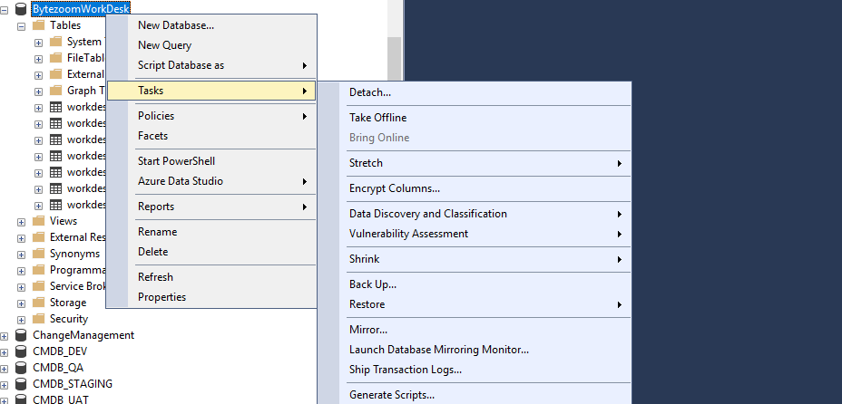

1. Click Next.



1. Click Next.



1. Click Advanced.



1. Set Types of data to script to Schema and Data.



1. Click OK.



1. Set File Name to script.sql.



1. Click Next.



1. Click Next.



1. Click Finish.



K2 Forms, views and SmartObjects

1. Open K2 Package and Deployment.

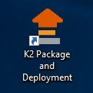

1. Select DEV server.



1. Click Create New Package.



1. Set Package Name to BytezoomWorkdesk.



1. Click Next.



1. Click Add Item.



1. Select Bytezoom Workdesk folder.



1. Click OK.



1. Click Finish.



## Bytezoom Workdesk Deployment

SQL database schema and data

1. Open Microsoft SQL Server Management Studio.



1. Right Click on Databases in Object Explorer.



1. Select New Database.



1. Set Database name to BytezoomWorkdesk.



1. Click OK.



1. Open script.sql.

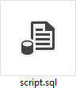

1. Click Execute.



Service Instance

1. Open SmartObject Service Tester.

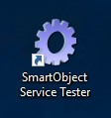

1. Click Register ServiceInstance.



1. Set Service Types to SQL Server Service.



1. Set AuthenticationMode to ServiceAccount.



1. Set Database to BytezoomWorkdesk.



1. Set Database to sql01-n.



1. Click Next.



15. Set Guid to 531f1e55-b8cc-4537-87ee-71f551b39327.



1. Click Add.



1. Click OK.



K2 Forms, views, SmartObjects

1. Open K2 Package and Deployment.



1. Select QA/PROD server in K2 Package and Deployment.
2. Click Deploy Package.



1. Click Browse.



1. Select package BytezoomWorkdesk.kspx.
2. Click Open.



1. Click Next.



1. Click Next.



1. Click Finish.



them.

Workdesk is a tool, which helps to manage applications, this section describes how to configure

## Workdesk Settings

On the Workdesk Settings tab you can add applications, logos, menu links, users and determine

their roles, also manage the appearance changing colors and fonts. To config applications there are views on the Workdesk Settings tab:

* + Configurations
  + Logos
  + Applications
  + Workdesks
  + Links
  + Roles
  + Role Members

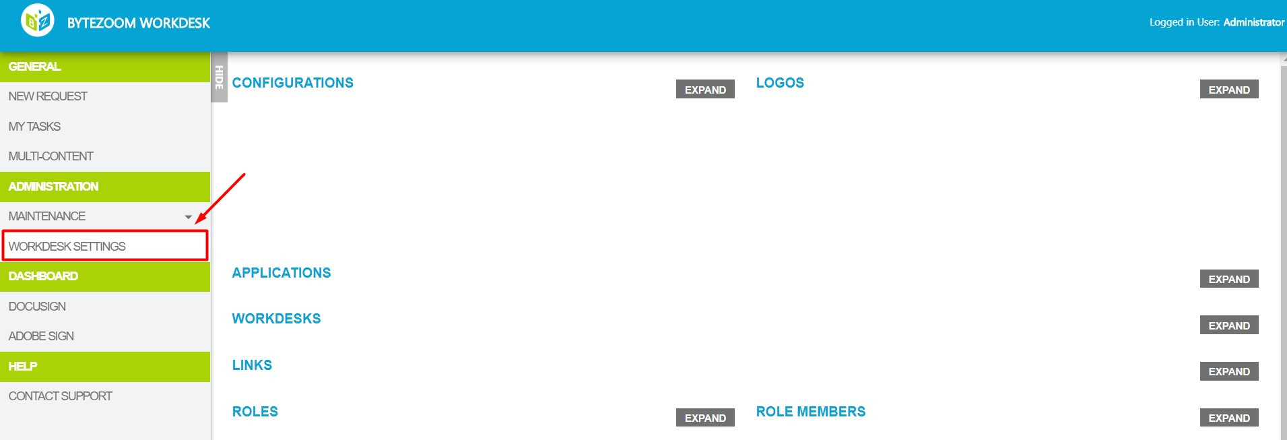

## Configurations

This view helps to configure color of the text, background, borders etc.

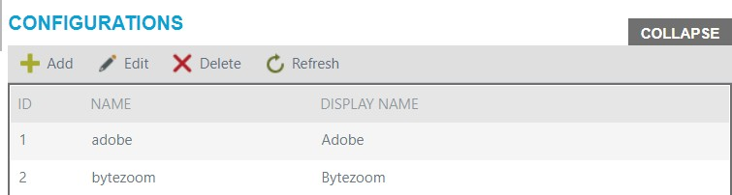

Buttons:

* + Add
  + Edit
  + Delete
  + Refresh

### Add

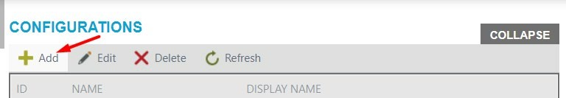To add configurations click Add button.

Add button opens a panel, where you should fill in required fields to config the appearance of application.

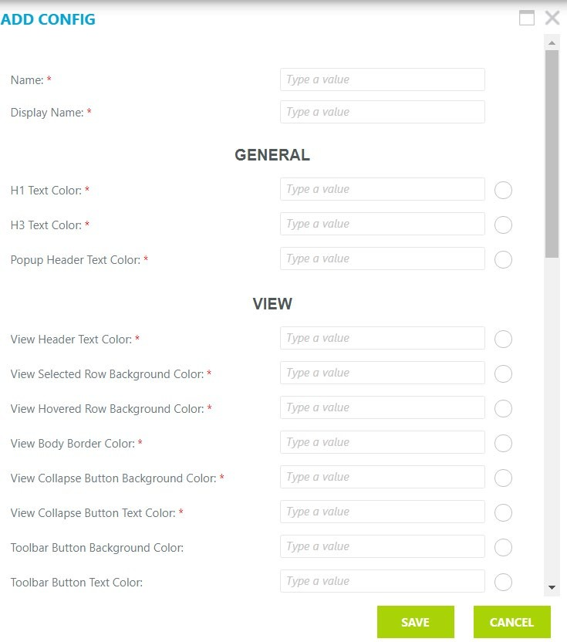

When you enter the color number you can see how it looks like on the nearby circle.

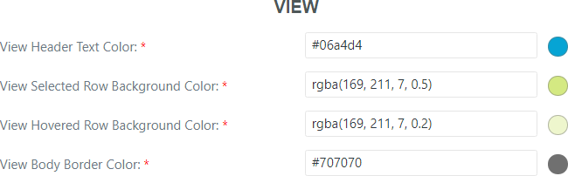

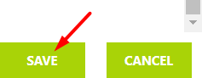After you fill in all required fields, click on the Save button.

*Note, Cancel button will cancel changes.*

### Edit

To modify configurations, select the row you need and click on the Edit button.

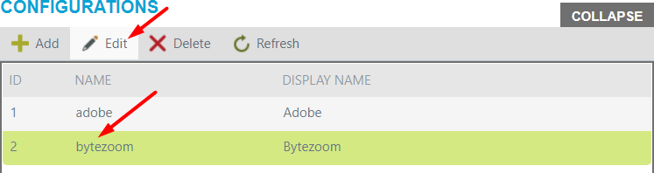

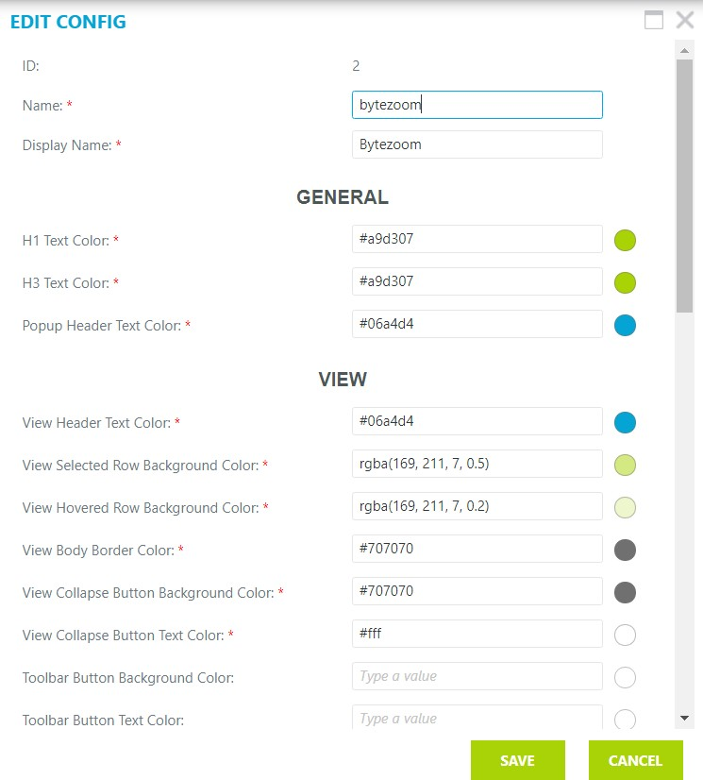Edit button opens a panel, where you can edit configurations.

After making changes, click Edit button on the panel.

*Note, Cancel button will cancel changes.*

### Delete

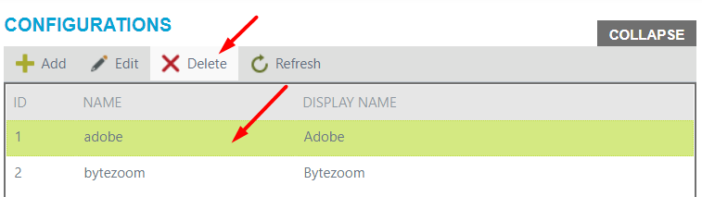To delete configurations, select required row and click on the Delete button.

### Refresh

To refresh the list, click Refresh button.

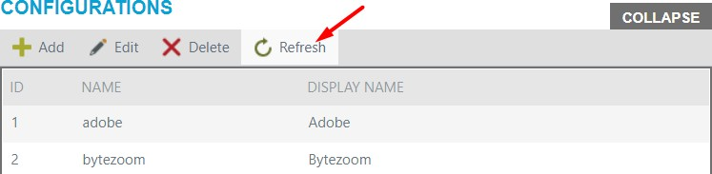

## Logos

This view helps you to configure images.

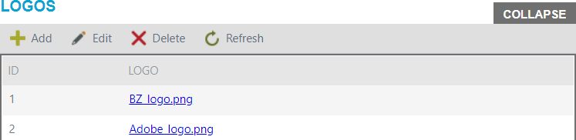

Buttons:

* + Add
  + Edit
  + Delete
  + Refresh

### Add

To add new logo click on the Add button.

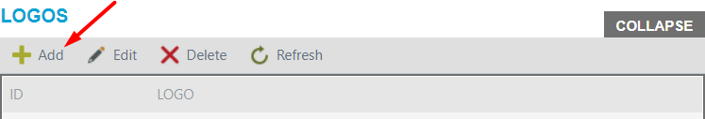

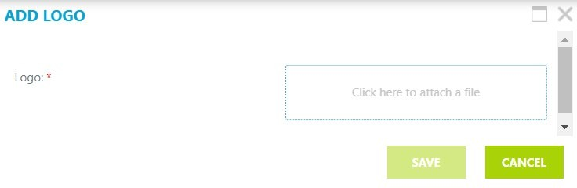Add button opens a panel, where you should attach a file.

After you attached a file, click on the Save button.



*Note, cancel button will cancel changes.*

### Edit

To modify the logo, select required row and click Edit button.

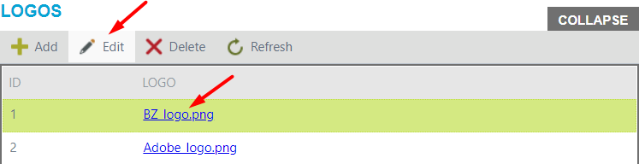

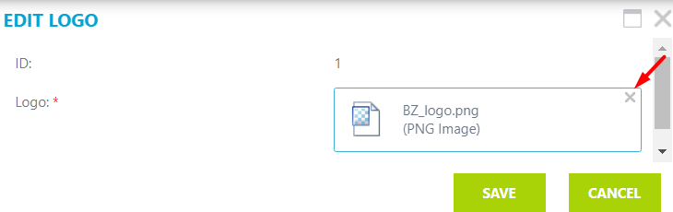Edit button opens a panel, where you should click on X and attach new logo file.

After you change the logo, click on the Save button.

*Note, cancel button will cancel changes.*

### Delete

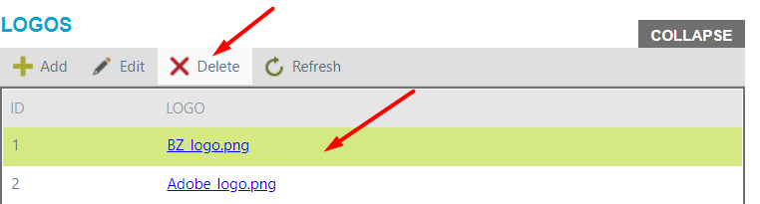To delete the logo, select required row and click on the Delete button.

### Refresh

To refresh the list, click Refresh button.

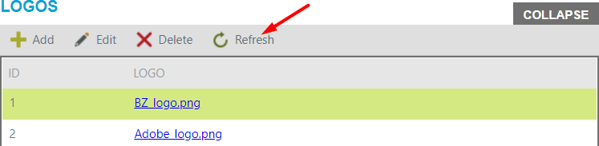

## Applications

Applications view helps to configure applications.

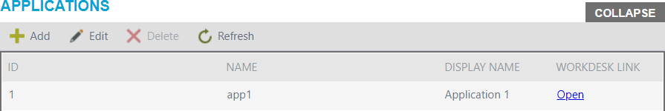

Buttons:

* + Add
  + Edit
  + Delete
  + Refresh

### Add

To add new application, click on the Add button.

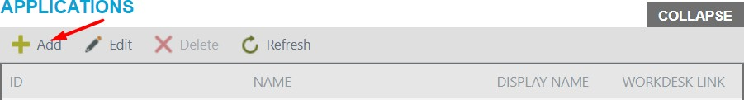

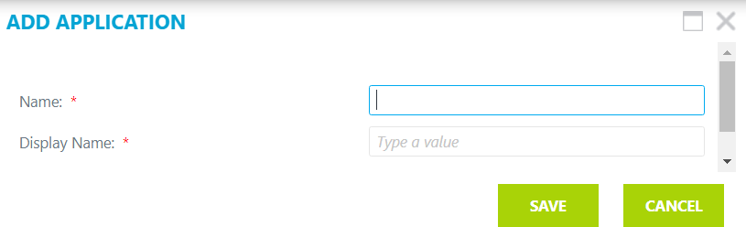Add button opens a panel, where you should enter the name of application.

After you enter the name, click on the Save button.



*Note, cancel button will cancel changes.*

The link to the application will be generated, you could see it on the Applications view.

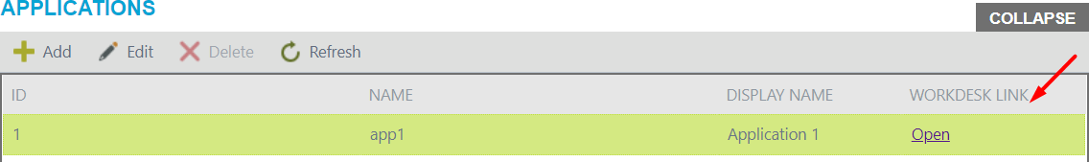

### Edit

To modify application click on application you are interested in and click Edit button.

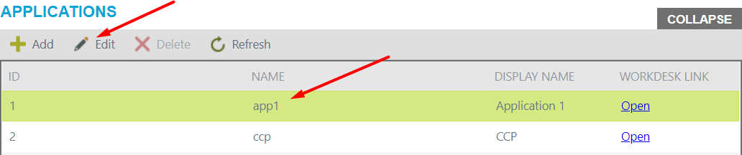

Edit button opens a panel, where you can make changes.

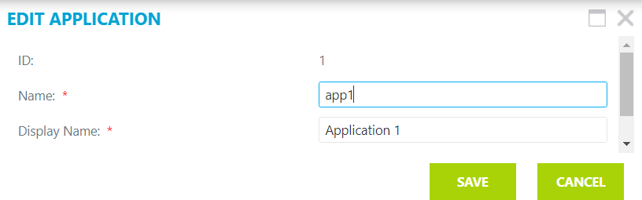

After editing the name, click on the Save button.

*Note, cancel button will cancel changes.*

### Delete

To delete the application, click on row you are interested in and click on the Delete button.

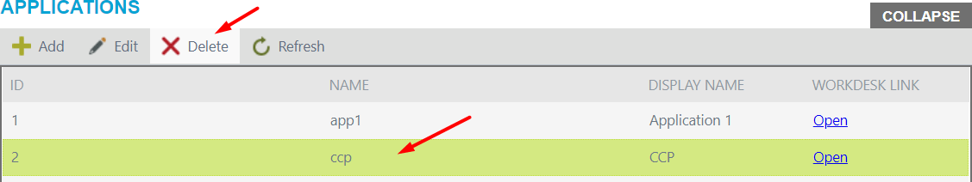

### Refresh

To refresh the list, click on the Refresh button.

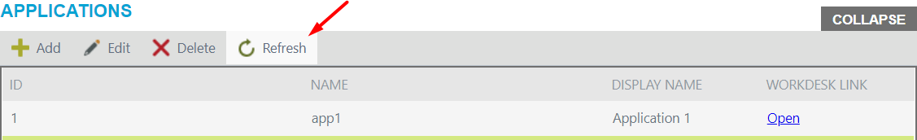

## Workdesks

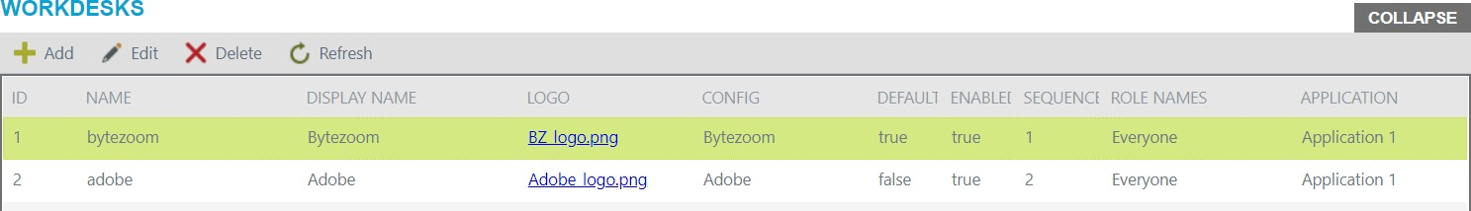This view helps to config Workdesks, that will be on your application.

Buttons:

* + Add
  + Edit
  + Delete
  + Refresh

### Add

To add new Workdesk, select application from Applications view and then click on the Add button on the Workdesk view.

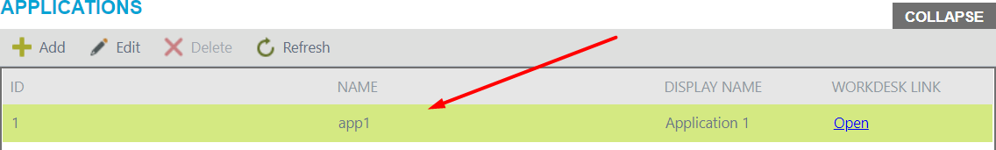

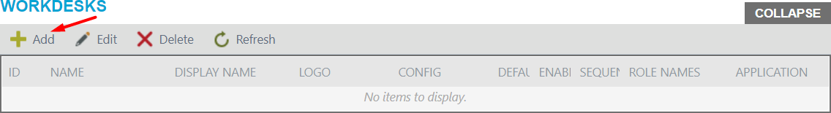

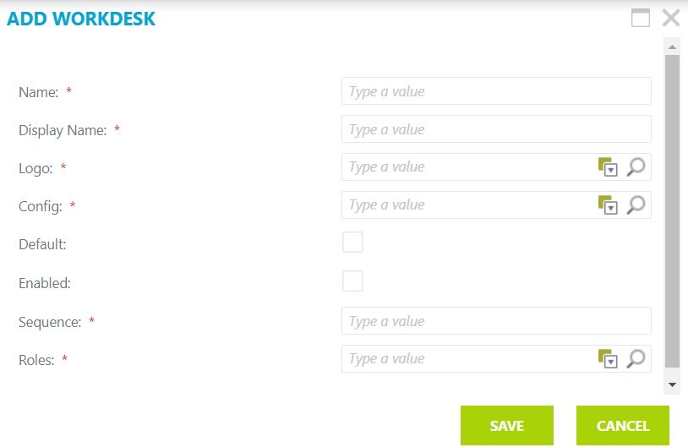Add button opens a panel.

On the panel, you should enter the name and display name of workdesk. Choose the logo and config from ones, that you add on Logos and Configurations views, respectively. If you check Default checkbox, this workdesk would be opened when you start Wokdesk tool. If you check Enabled checkbox, this workdesk will be available to see. Then you should enter the sequence of workdesk, where workdesks would be shown. After that, choose roles of users, who can see the workdesk, there are could be several roles.

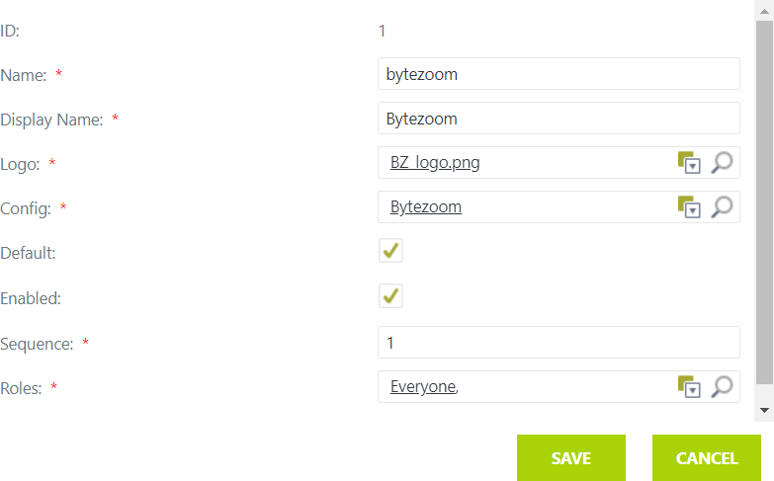

After adding, click on the Save button.

*Note, cancel button will cancel changes.*

### Edit

To modify workdesk, select application from Applications view, then click on the required workdesk on the Workdesk view and click on the Edit button.

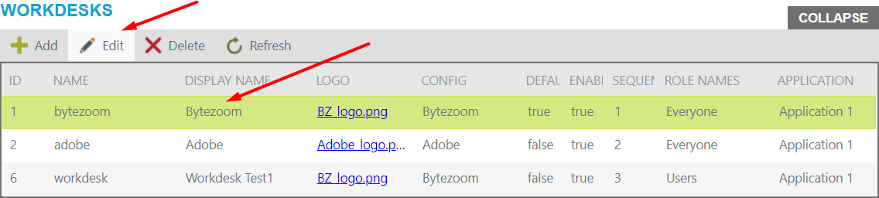

Edit button opens a panel, where you should make changes.

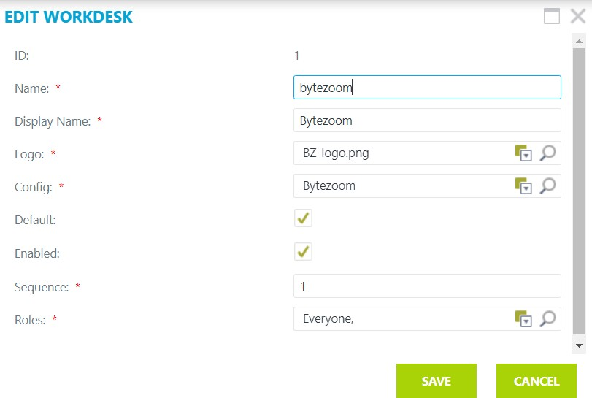

After making changes, click on the Save button.

*Note, cancel button will cancel changes.*

### Delete

To delete the workdesk, select application from Applications view, then click on the workdesk you are interested in and click the Delete button.

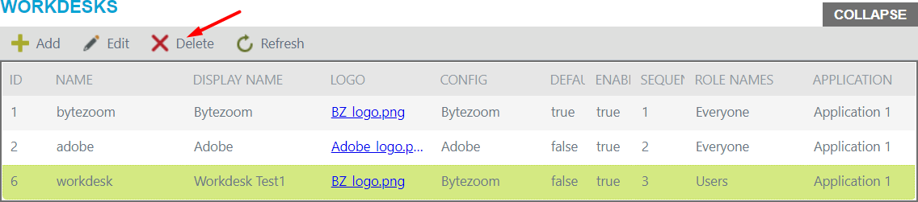

### Refresh

To refresh the list, click Refresh.

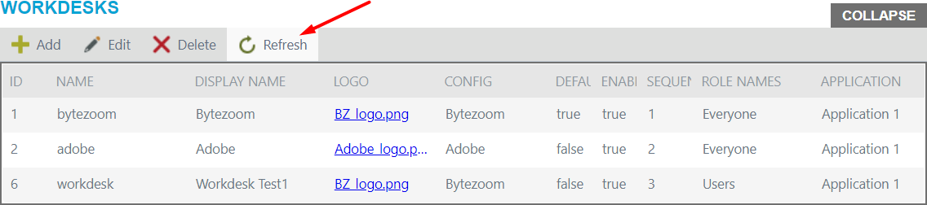

## Links

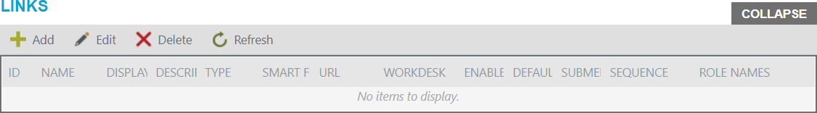Links view helps to confing links on your workdesk.

Buttons:

* + Add
  + Edit
  + Delete
  + Refresh

*Note, to configure links you should at first select application from the Applications view and workdesk from the Workdesk view, where you will use links.*

To add new link, select application and workdesk, then click Add button on the Links view.

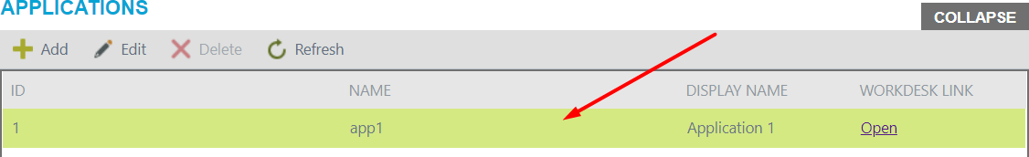

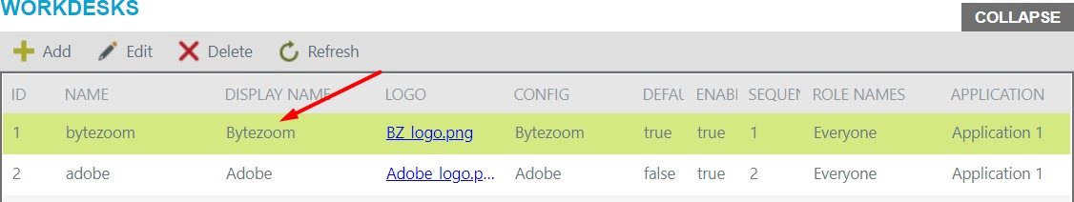

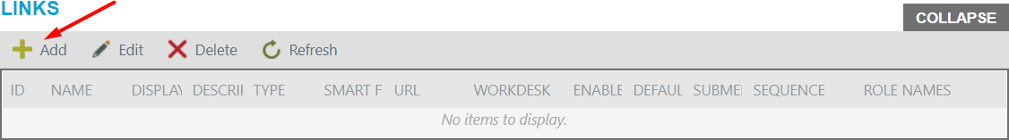

Add button opens a panel.

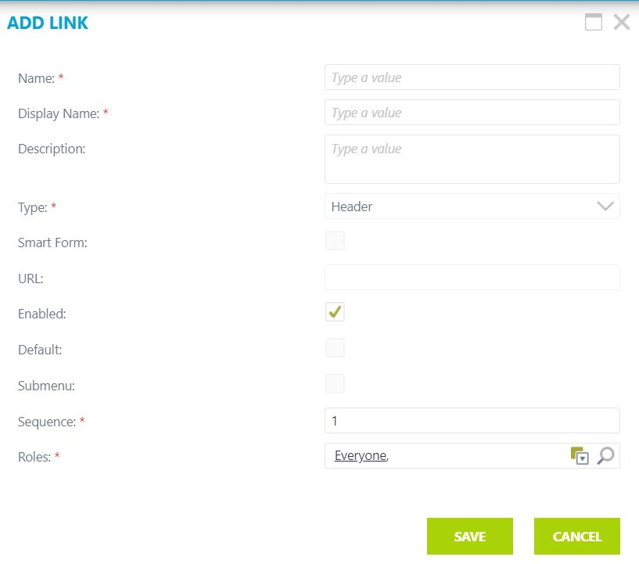If you create first link for workdesk, default it would be header link.

Enter name and display name. Fill in the Description field if you need. Choose the type from the drop-down list, it could be link or header. If you do not choose the Smart Form checkbox, you should enter the whole URL address, otherwise you need to enter only part of it, for example:

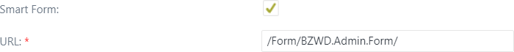

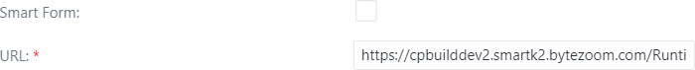

If you check Default checkbox, this link will be open, when you open the Wokdesk. If you check Enabled checkbox, this link will be available to see. Check in Submenu checkbox if you want this link to be in submenu of other link. Then you should choose the sequence of link on left side bar. After, choose roles of users, who can see the link, there are could be several roles.

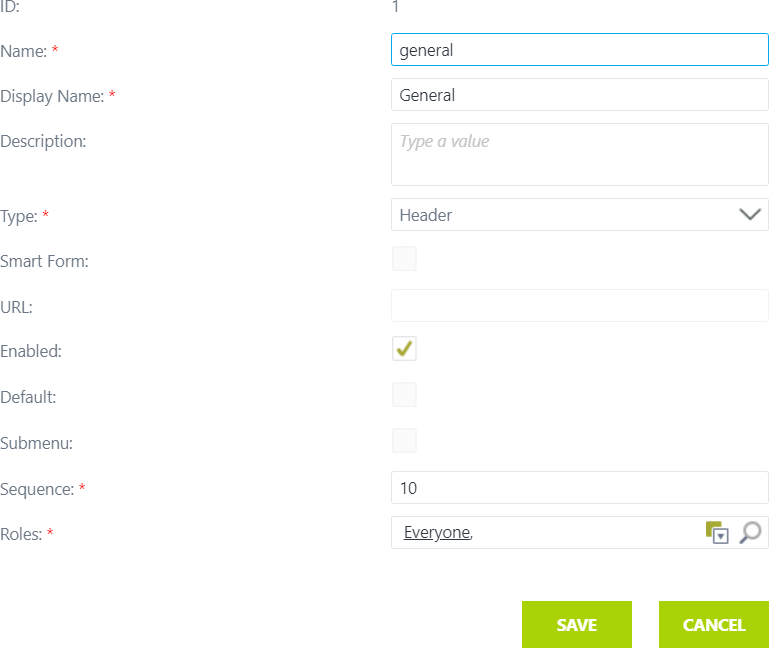

After adding, click on the Save button.



*Note, cancel button will cancel changes.*

### Edit

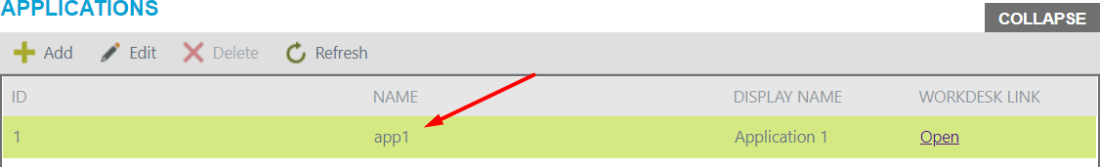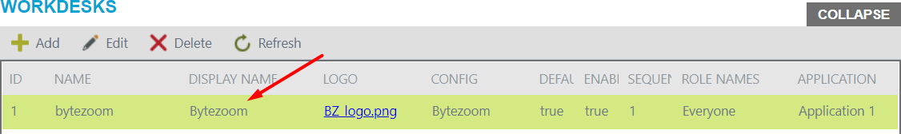To modify the link, select application and workdesk, then click on the link row you interested in and click Edit button.

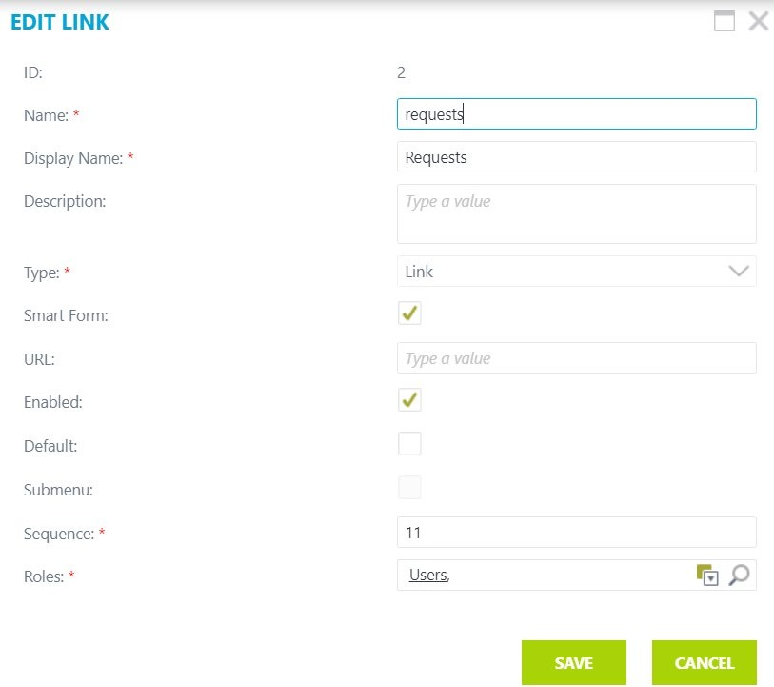Edit button opens a panel, where you should make changes.

After editing the link, click on the Save button.



*Note, cancel button will cancel changes.*

### Delete

To delete the link, select application and workdesk, click on the link row on the Links view and click the Delete button.

### Refresh

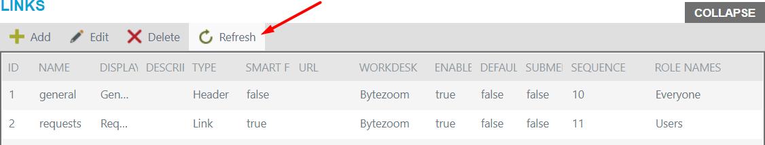To refresh the list, click Refresh.

## Roles

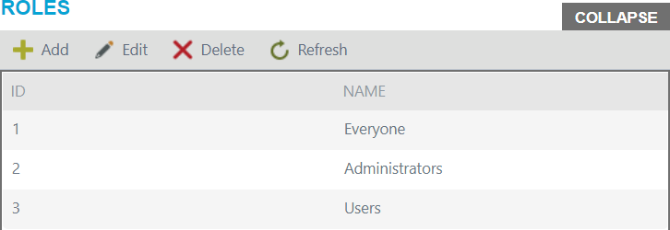This view used for assigning roles.

Buttons:

* + Add
  + Edit
  + Delete
  + Refresh

### Add

To add new role, click on the Add button.

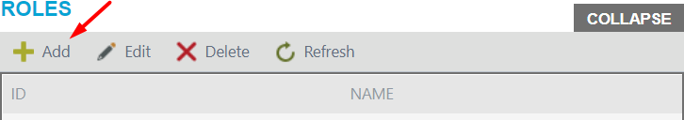

Add button opens a panel, where you should enter the name of the role.

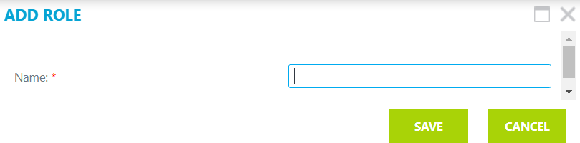

After you enter the name, click on the Save button.

*Note, cancel button will cancel changes.*

### Edit

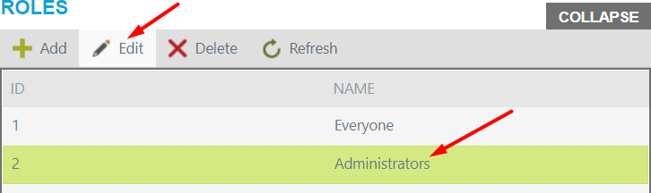To modify role, click on the row you interested in and click Edit button.

Edit button opens a panel, where you should rename the role.

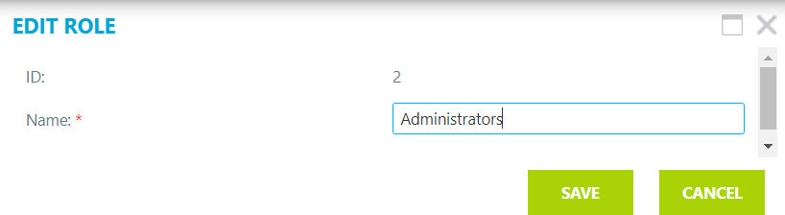

After making changes, click on the Save button.

*Note, cancel button will cancel changes.*

### Delete

To delete the role, select required row and click on the Delete button.

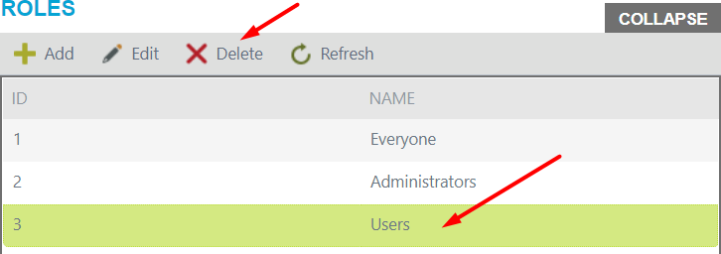

*Note, users cannot edit or delete the same role they are.*

### Refresh

To refresh the list, click Refresh.

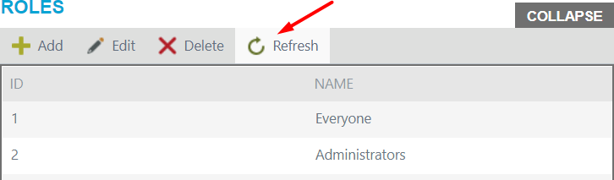

## Roles members

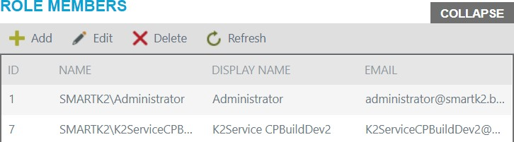This view for assigning members to the role.

Buttons:

* + Add
  + Edit
  + Delete
  + Refresh

### Add

To add new role member, first select the role from the Roles view and click on the Add button the Role Members view.

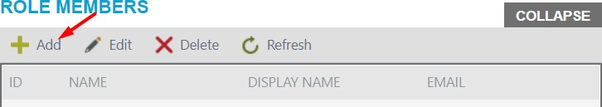

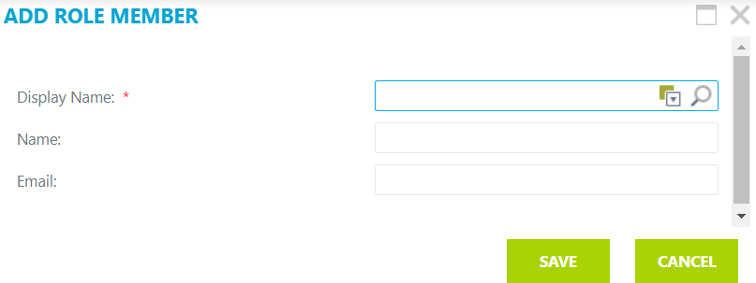Add button opens a panel, where you should fill in fields.

After you add a role member, click on the Save button.



*Note, cancel button will cancel changes.*

### Edit

To modify role member information, select role from Roles view, then select role member you interested in and click Edit button.

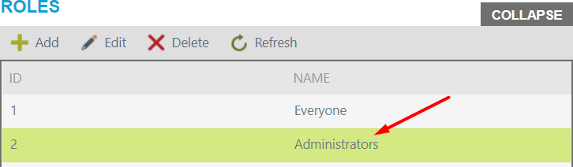

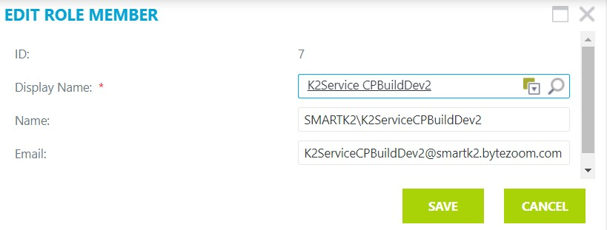Edit button opens a panel, where you should make changes.

After making changes, click on the Save button.



*Note, cancel button will cancel changes.*

### Delete

To delete, click on the role you are interested in and click the Delete button.

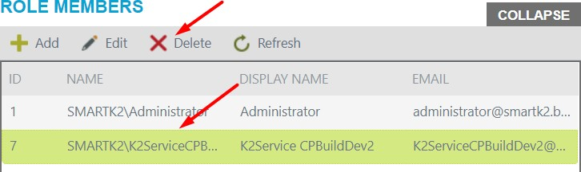

### Refresh

To refresh the list, click Refresh.

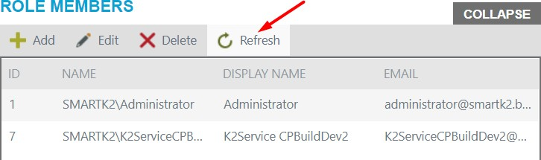

*Note, users cannot edit or delete themselves.*